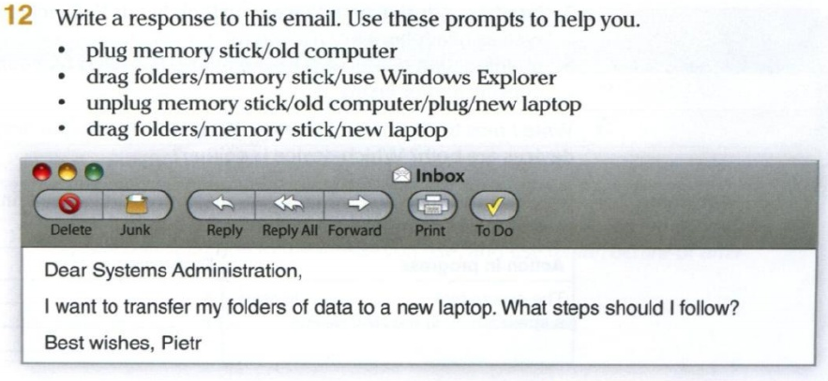

Subject: Re: Data Transfer Assistance
Dear Pietr,
I'd be happy to guide you through the process of transferring your data folders to your new laptop. Here are the steps you can follow:
- Plug Memory Stick into Old Computer: Begin by plugging your memory stick into your old computer where the data folders are currently stored.
- Drag Folders to Memory Stick using Windows Explorer: Open Windows Explorer on your old computer and locate the folders you wish to transfer. Then, simply drag and drop these folders onto your memory stick to copy them.
- Safely Unplug Memory Stick from Old Computer: Once the transfer is complete, safely eject the memory stick from your old computer to ensure no data loss.
- Plug Memory Stick into New Laptop: Now, insert the memory stick into your new laptop.
- Drag Folders from Memory Stick to New Laptop: Open Windows Explorer on your new laptop and navigate to the memory stick. From there, drag the folders you copied earlier onto your new laptop's storage to complete the transfer.
By following these steps, you should be able to successfully transfer your data folders from your old computer to your new laptop. If you encounter any difficulties, feel free to reach out for further assistance.
Best regards, JUAN CARLOS FRANCISCO MESA
2DAW SEMI A

Juan Carlos Francisco Mesa.
2º DAW Semi A

